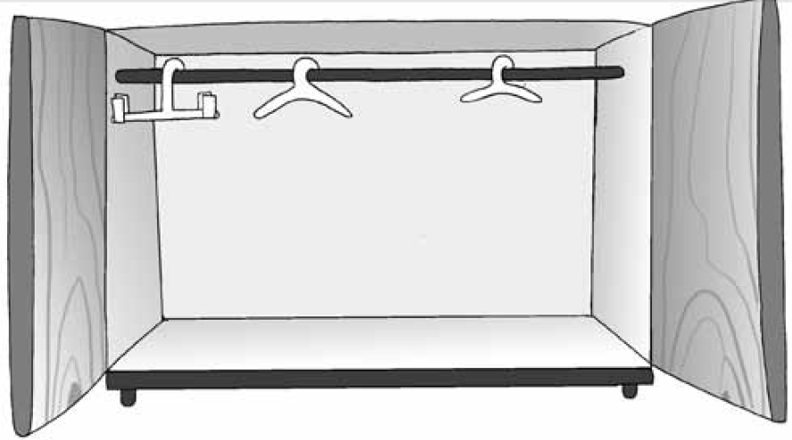 **What are your favourite clothes? Draw them in the wardrobe!** 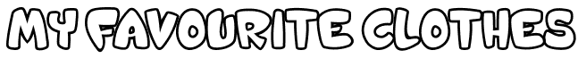

**Now complete: what are you wearing today?!**

Adjective Colour Clothes

Today I’m wearing ……………………………… …………………………… ……………………………

……………………………… …………………………… ……………………………

……………………………… …………………………… ……………………………

……………………………… …………………………… ……………………………

……………………………… …………………………… ……………………………

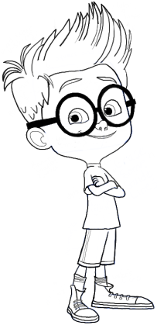V X S W B Q E R C S U H

A P T H O R T S R M O P

Y Y S A C V A E U O Z T

U T H E U A S C D O L J

BELT JUMPER

TRAINERS BLOUSE

TROUSERS BRACELET

TSHIRT COAT

WATCH CAP

HOODIE

L C I I W U P I E E L Q

S X R W O O E H B L J B

H D T R A I N E R S E C

C Y T X R E P M U J J T

T E R A K J S R P O W V

A L J N A P B M L T K F

W C O A T C H K O G T L

F C W N C S P U F K L R